# Practice Test 2

### **Question 1**

Domain :Design Azure data storage solutions

A company wants to deploy a Cosmos DB account. The data within the account will be used by data engineers situated across the world. You need to ensure that data engineers worldwide can access the data for a read operation with the least amount of latency. You also need to ensure that costs are minimized. Which of the following would you implement for this requirement?

]A.

**Create a single Azure Cosmos DB account and enable multi-region writes.**

]B.

**Create a single Azure Cosmos DB account and configure data replication.**

]C.

**Create a single Azure Cosmos DB account and configure geo-redundancy.**

]D.

**Create multiple Azure Cosmos DB accounts for each region.**

**Explanation:**

Answer – B

You can just create a single Azure Cosmos DB account. Then configure data replication so that data is replicated to multiple regions where the data engineers are situated.

The Microsoft documentation mentions the following.

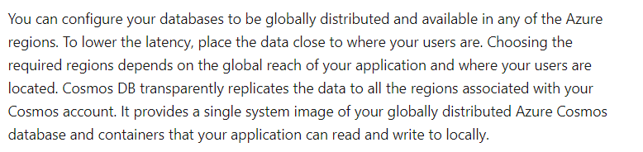

### Option A is incorrect since the Question mentions that we need to ensure latency to read requests is reduced.

Option C is incorrect since we need to enable data replication and not geo-redundancy.

Option D is incorrect since we can just have one Azure Cosmos DB account and enable data replication.

For more information on distributing data globally with Cosmos DB, please visit the below URL-

* <https://docs.microsoft.com/en-us/azure/cosmos-db/distribute-data-globally>

### **Question 2**

Domain :Design for data security and compliance

You have an Azure Data Lake Storage Gen 2 account. You have to grant permissions to a specific application for a limited time period. Which of the following can you use for this requirement?

]A.

**Access keys for the storage account**

]B.

**A shared access signature**

]C.

**Role based access control**

]D.

**Azure AD Users**

**Explanation:**

Answer – B

The most secure way is to use a shared access signature.

The Microsoft documentation mentions the following.

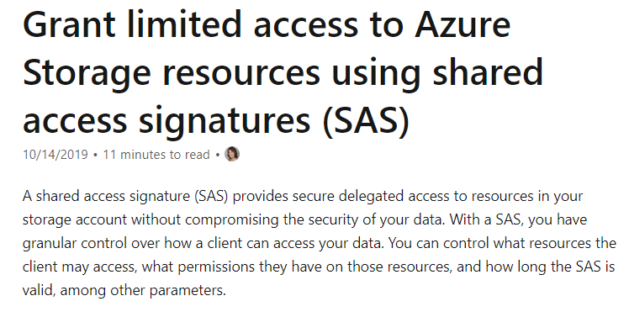

Option A is incorrect since this would give access to the entire storage account.

Option C is incorrect since this is used for control place permissions to the storage account.

Option D is incorrect since you would not use Azure AD users to give permissions at the application level.

For more information on shared access signature, please visit the below URL-

* <https://docs.microsoft.com/en-us/azure/storage/common/storage-sas-overview>

### **Question 3**

Domain :Design for data security and compliance

A company is planning to set an Azure SQL Database. The database contains tables and columns that contain sensitive data. The company wants to have a solution in place that would accomplish the following requirements.

* Ensure the database is encrypted at rest.
* Ensure that when sensitive data is accessed from the columns, it is encrypted in transit.

Which of the following would you use for the following requirement?

**“Ensure the database is encrypted at rest.”**

]A.

**Always Encrypted**

]B.

**Dynamic data masking**

]C.

**Row-level security**

]D.

**Transparent Data Encryption**

**Explanation:**

Answer – D

You can use Transparent Data Encryption to encrypt the data at rest.

The Microsoft documentation mentions the following.

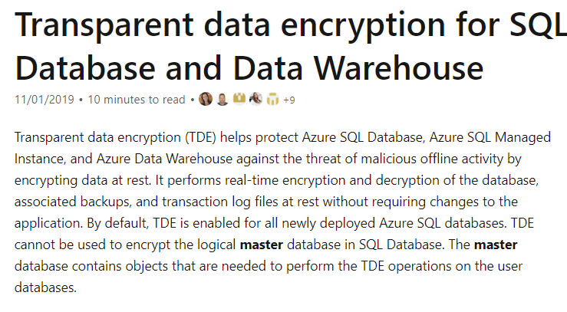

Option A is incorrect since this is used to protect data in transit and is used as a column level.

Option B is incorrect since this is used to just mask data values from users.

Option C is incorrect since this is just used to provide security at the row-level.

For more information on transparent data encryption, please visit the below URL-

* <https://docs.microsoft.com/en-us/azure/sql-database/transparent-data-encryption-azure-sql?tabs=azure-portal>

### **Question 4**

Domain :Design for data security and compliance

A company is planning to set an Azure SQL Database. The database contains tables and columns that contain sensitive data. The company wants to have a solution in place that would accomplish the following requirements.

* Ensure the database is encrypted at rest.
* Ensure that when sensitive data is accessed from the columns, it is encrypted in transit.

Which of the following would you use for the following requirement?

**“Ensure that when sensitive data is accessed from the columns, it is encrypted in transit.”**

]A.

**Always Encrypted**

]B.

**Dynamic data masking**

]C.

**Row-level security**

]D.

**Transparent Data Encryption**

**Explanation:**

Answer – A

You can use Always Encrypted to encrypt the data in transit. This is normally used at a column level.

The Microsoft documentation mentions the following.

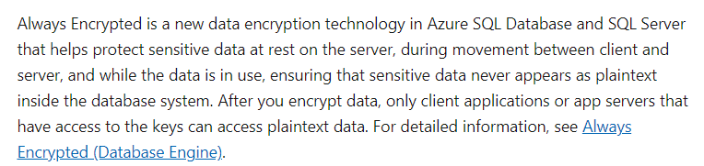

Option B is incorrect since this is used to just mask data values from users.

Option C is incorrect since this is just used to provide security at the row-level.

Option D is incorrect since this is used to encrypt the entire database.

For more information on always encrypted for Azure SQL Database, please visit the below URL-

* <https://docs.microsoft.com/en-us/azure/sql-database/sql-database-always-encrypted>

### **Question 5**

Domain :Design for data security and compliance

You have an Azure SQL database. You need to provide an Azure AD group read access to the database. Which of the following would you use to provide access?

]A.

**A contained database user**

]B.

**Role based access control**

]C.

**Access keys**

]D.

**Shared Access Signature**

**Explanation:**

Answer – A

You would use a contained database user to provide access to Azure AD principals.

This is also given in the Microsoft documentation.

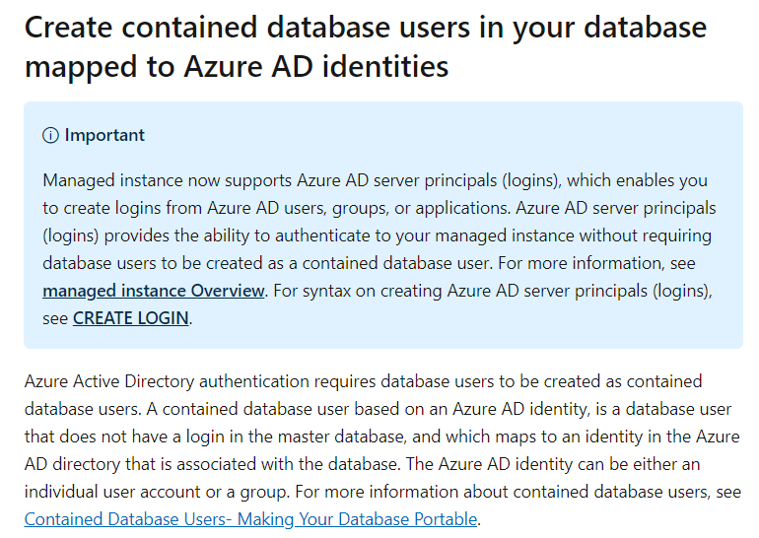

Since this is clearly given in the documentation, all other options are incorrect.

For more information on configuring Azure AD authentication, please visit the below URL-

* <https://docs.microsoft.com/en-us/azure/sql-database/sql-database-aad-authentication-configur>

### **Question 6**

Domain :Design Azure data storage solutions

You need to design a solution that would use Azure Functions. The function would be used to process data that is uploaded to Azure Blob storage. You have to ensure that the following requirements are met.

* The solution must have support for 1 million blobs.
* The solution must scale automatically.
* Costs must be minimized.

Which of the following would you recommend for this requirement?

]A.

**Deploying the Azure Function as part of an App Service Plan and then using the Blob trigger**

]B.

**Deploying the Azure Function as part of an App Service Plan and then using the Event trigger**

]C.

**Deploying the Azure Function as part of a Consumption Plan and then using the Blob trigger**

]D.

**Deploying the Azure Function as part of a Consumption Plan and then using the Event trigger**

**Explanation:**

Answer – C

You can create the Azure Function based on the Consumption Plan. With the Consumption plan, you minimize costs and scaling happens automatically.

The Microsoft documentation mentions the following.

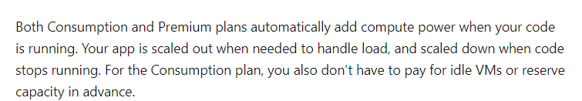

You can also use Blob triggers to allow Azure Function to automatically process data in Blob storage.

Options B and D are incorrect since we need to use a Blob trigger.

Option A is incorrect because this would not be a cost-effective option.

For more information on scaling Azure Functions and using blob triggers, please visit the below URL-

* <https://docs.microsoft.com/en-us/azure/azure-functions/functions-scale>
* <https://docs.microsoft.com/en-us/azure/azure-functions/functions-create-storage-blob-triggered-function>

### **Question 7**

Domain :Design data processing solutions

A company wants to design a solution that would support the ingestion and analysis of log files in real-time. Which of the following would you implement for this requirement? Choose 2 answers from the options given below.

A.

**Azure Databricks**

B.

**Azure Data Factory**

C.

**Azure Event Hubs**

D.

**Azure Data Lake Gen 2 storage**

**Explanation:**

Answer – A and C

You can use Azure Event Hubs to ingest the data.

The Microsoft documentation mentions the following.

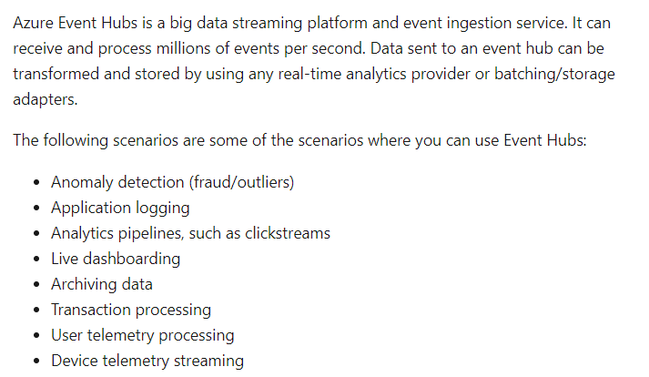

And you can use Azure databricks for processing the data.

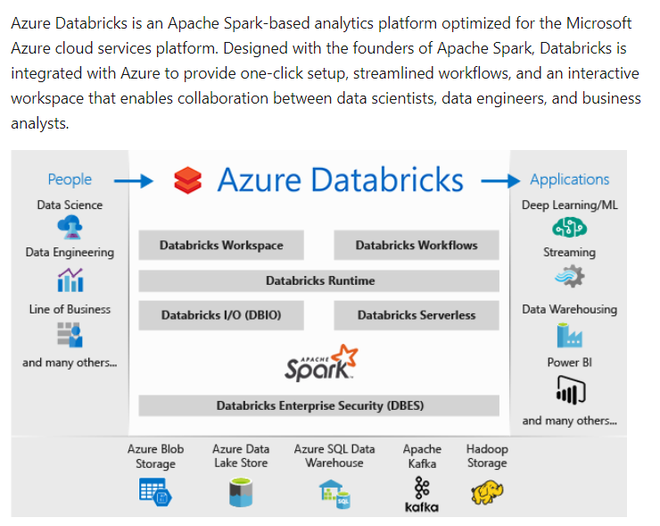

Option A is incorrect since this is a data transfer and transformation service.

Option D is incorrect since this is used for Big Data storage purposes.

For more information on Azure Event Hubs and Azure Databricks, please visit the below URL-

* <https://docs.microsoft.com/en-us/azure/azure-databricks/what-is-azure-databricks>
* <https://docs.microsoft.com/en-us/azure/event-hubs/event-hubs-about>

### **Question 8**

Domain :Design data processing solutions

A company is planning to design a solution in Azure. The solution would be based on the Kappa architecture as shown below.

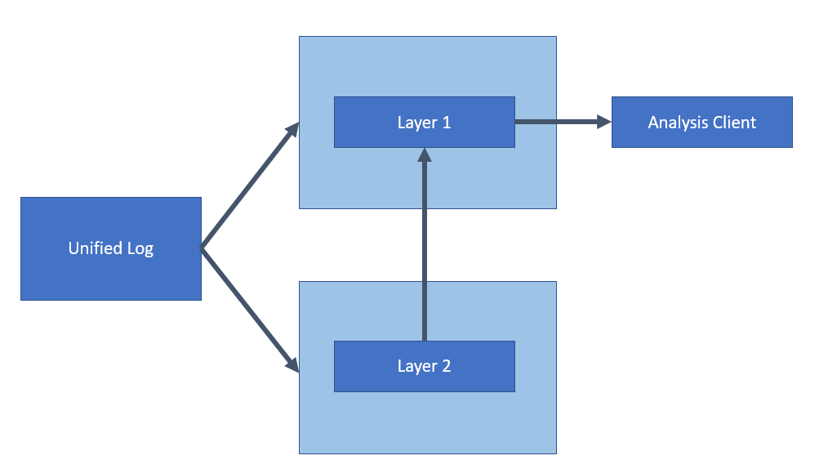

Which of the following could be used for Layer 1?

]A.

**Azure Cosmos DB**

]B.

**Azure Data Catalog**

]C.

**Azure Data Factory**

]D.

**Azure SQL Data Warehouse**

**Explanation:**

Answer – A

If you look at the Kappa architecture in the Microsoft documentation, Layer 1 corresponds to a speed layer wherein the data can be accessed easily. Cosmos DB would fit this requirement, since you can access data easily from a Cosmos DB database.

The Microsoft documentation mentions the following.

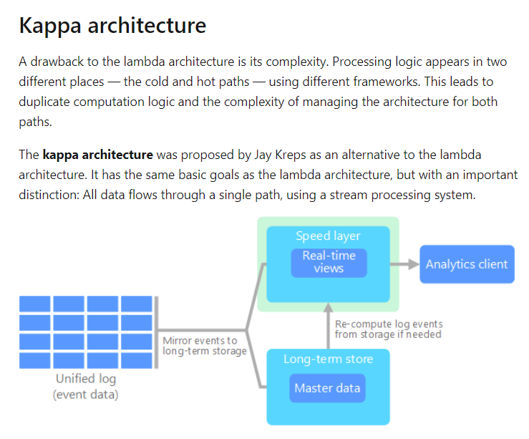

Option B is incorrect since this is a metadata catalog.

Option C is incorrect since this is used for the data transfer and conversion process.

Option D is incorrect since this is used as a data warehousing solution.

For more information on Big Data architectures, please visit the below URL-

* <https://docs.microsoft.com/en-us/azure/architecture/data-guide/big-data/>

### **Question 9**

Domain :Design data processing solutions

A company is planning to design a solution in Azure. The solution would be based on the Kappa architecture as shown below.



Which of the following could be used for Layer 1?

]A.

**Azure Cosmos DB**

]B.

**Azure Data Catalog**

]C.

**Azure Data Factory**

]D.

**Azure SQL Data Warehouse**

**Explanation:**

Answer – D

If you look at the Kappa architecture in the Microsoft documentation, Layer 2 corresponds to a Long- term data store. Azure SQL data warehouse would be a perfect fit for this requirement.

The Microsoft documentation mentions the following.



Option A is incorrect since this is should be used as Layer 1 for the architecture.

Option B is incorrect since this is a metadata catalog.

Option C is incorrect since this is used for the data transfer and conversion process.

For more information on Big Data architectures, please visit the below URL-

* <https://docs.microsoft.com/en-us/azure/architecture/data-guide/big-data/>

### **Question 10**

Domain :Design data processing solutions

A company wants to make use of an Azure Databricks interactive cluster. The cluster would be configured for auto-termination. The company wants to ensure that the cluster configuration remains indefinitely after the cluster is terminated. The company also wants to ensure that costs are minimized when implementing the solution. Which of the following would you implement for this requirement?

]A.

**Ensure to clone the cluster.**

]B.

**Ensure to create an Azure runbook to start the cluster.**

]C.

**Ensure to pin the cluster.**

]D.

**Ensure to disable termination for the cluster.**

**Explanation:**

Answer – C

To save the cluster configuration, you can go ahead and pin the cluster. This is also mentioned in the databricks documentation.

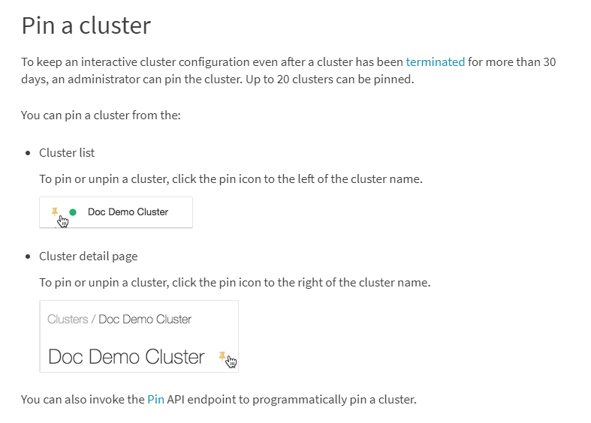

Since this is clearly mentioned in the documentation, all other options are incorrect.

For more information on managing clusters, please visit the below URL-

* <https://docs.databricks.com/clusters/clusters-manage.html>

### **Question 11**

Domain :Design Azure data storage solutions

A company wants to use an Azure Data Lake Storage account to store CSV files. These files will be organized into department wise folders. The company wants to ensure that data is configured in such a way that users will only see files in their respective department folders.

They decide to disable hierarchical namespace and use access control lists.

Would this fulfill the requirement?

]A.**Yes**

]B.**No**

**Explanation:**

Answer – B

You need to set the hierarchical namespace so that it can support folders.

The Microsoft documentation mentions the following.

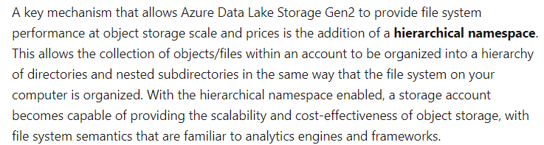

For more information on data lake storage namespaces, please visit the below URL-

* <https://docs.microsoft.com/en-us/azure/storage/blobs/data-lake-storage-namespace>

### **Question 12**

Domain :Design Azure data storage solutions

A company wants to use an Azure Data Lake Storage account to store CSV files. These files will be organized into department wise folders. The company wants to ensure that data is configured in such a way that users will only see files in their respective department folders.

They decide to enable hierarchical namespace and use RBAC.

Would this fulfill the requirement?

]A.**Yes**

]B.**No**

**Explanation:**

Answer – B

RBAC is used to provide permissions at the container level. At the folder level, you need to use access control lists.

The Microsoft documentation mentions the following.

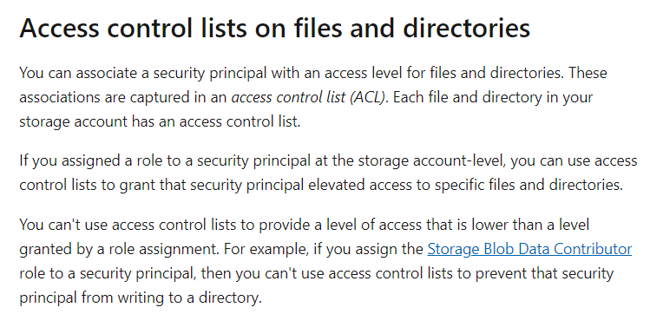

For more information on data lake storage access control, please visit the below URL-

* <https://docs.microsoft.com/en-us/azure/storage/blobs/data-lake-storage-access-control>

### **Question 13**

Domain :Design Azure data storage solutions

A company wants to use an Azure Data Lake Storage account to store CSV files. These files will be organized into department wise folders. The company wants to ensure that data is configured in such a way that users will only see files in their respective department folders.

They decide to disable the hierarchical namespace and use RBAC.

Would this fulfill the requirement?

]A.**Yes**

]B.**No**

**Explanation:**

Answer – B

You need to set the hierarchical namespace so that it can support folders.

RBAC is used to provide permissions at the container level. At the folder level, you need to use access control lists.

The Microsoft documentation mentions the following.





For more information on data lake storage access control and data lake storage namespaces, please visit the below URL-

* <https://docs.microsoft.com/en-us/azure/storage/blobs/data-lake-storage-access-control>
* <https://docs.microsoft.com/en-us/azure/storage/blobs/data-lake-storage-namespace>

### **Question 14**

Domain :Design Azure data storage solutions

A company wants to implement a big data store. Below are the key requirements for the data store.

* It should have support for a hierarchical file system.
* It should be optimized for parallel analytic workloads.
* It should provide unlimited account sizes.

Which of the following would you implement for this requirement?

]A.

**Azure Data Lake Storage Gen2**

]B.

**Azure Blob storage**

]C.

**Apache HBase in Azure HDInsight**

]D.

**Azure Cosmos DB**

**Explanation:**

Answer – A

The ideal data store which has a hierarchical file system is Azure Data Lake Storage Gen2.

The Microsoft documentation mentions the following.

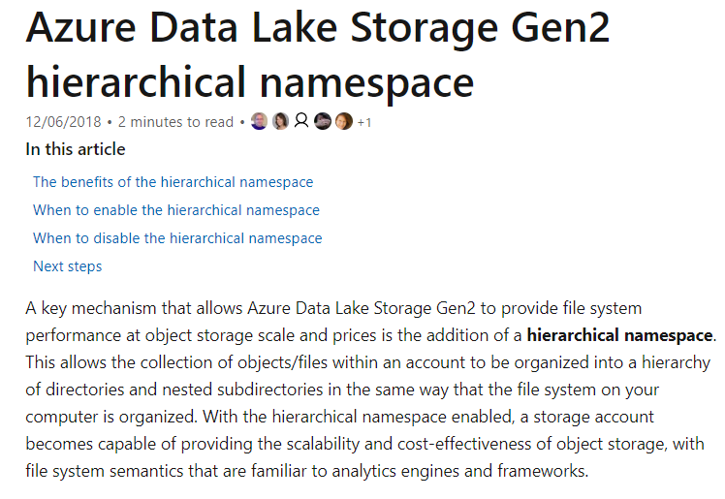

Since this is clearly mentioned in the documentation, all other options are incorrect.

For more information on Azure data lake storage namespaces, please visit the below URL-

* <https://docs.microsoft.com/en-us/azure/storage/blobs/data-lake-storage-namespace>

### **Question 15**

Domain :Design Azure data storage solutions

A company wants to implement an Azure Cosmos DB database that would support data storage for vertices and edges. Which of the following would you use as the underlying Cosmos DB API?

]A.

**SQL**

]B.

**Cassandra**

]C.

**Gremlin**

]D.

**Table**

**Explanation:**

Answer – C

With the Gremlin API, you can store data as vertices and edges.

The Microsoft documentation mentions the following.

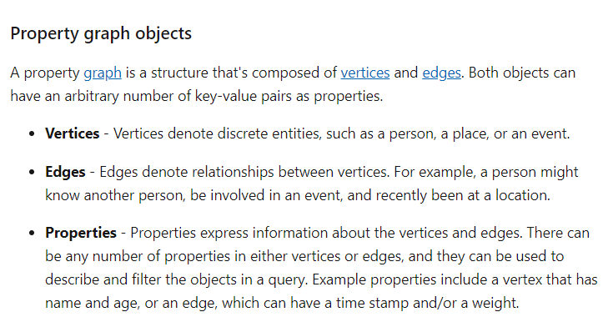

Since this is clearly mentioned in the documentation, all other options are incorrect.

For more information on Azure Cosmos DB Gremlin API, please visit the below URL-

* <https://docs.microsoft.com/en-us/azure/cosmos-db/graph-introduction>

### **Question 16**

Domain :Design Azure data storage solutions

A company wants to implement a data store that would meet the following requirements.

* Be able to receive thousands of files per minute.
* The files would be in different file formats – JSON, text and CSV.
* The files would eventually be processed, transformed and loaded into an Azure SQL data warehouse.

Which of the following would you use as the underlying data store?

]A.

**Azure Data Lake Storage Gen2**

]B.

**Azure Blob storage**

]C.

**Apache HBase in Azure HDInsight**

]D.

**Azure Cosmos DB**

**Explanation:**

Answer – A

The ideal store for this is Azure Data Lake Storage Gen2.

The Microsoft documentation mentions the following.

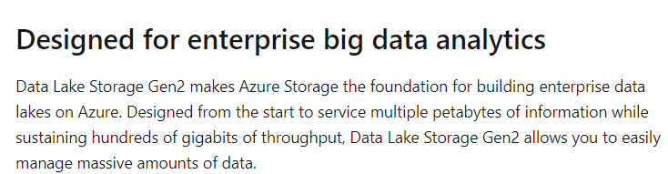

Option B is incorrect since Azure Data Lake Storage Gen2 is more geared up to receive thousands of files per minute since it acts as an ideal big data store.

Option C and D are incorrect since these are NoSQL data stores.

For more information on Azure Data Lake Storage Gen2, please visit the below URL-

* <https://docs.microsoft.com/en-us/azure/storage/blobs/data-lake-storage-introduction>

### **Question 17**

Domain :Design Azure data storage solutions

A company wants to migrate data from an on-premise Mongo DB Instance to Azure Cosmos DB – Mongo API. During the testing phase, they discovered that too much time is being taken for the migration process. Which of the following can they implement to reduce the migration time? Choose 2 answers from the options given below.

A.

**Increase the number of Request Units.**

B.

**Look to turn off indexing.**

C.

**Add an additional write region to the Cosmos DB account.**

D.

**Go ahead and create unique indexes.**

**Explanation:**

Answer – A and B

You can increase the number of Request Units and also turn off indexing.

The Microsoft documentation mentions the following.

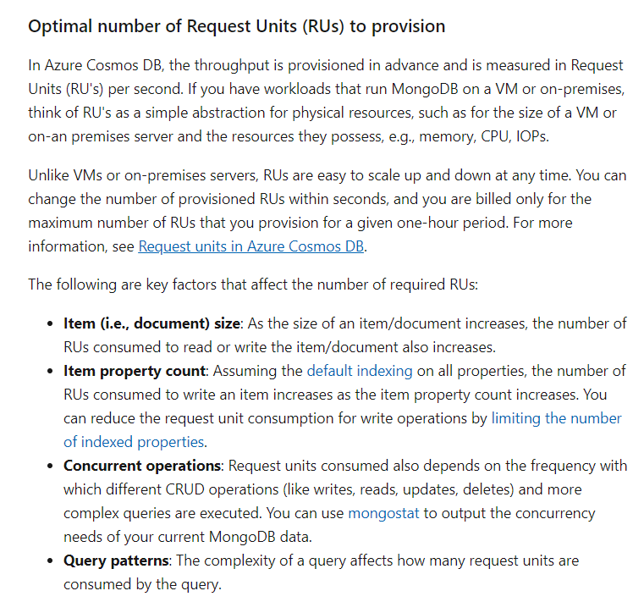

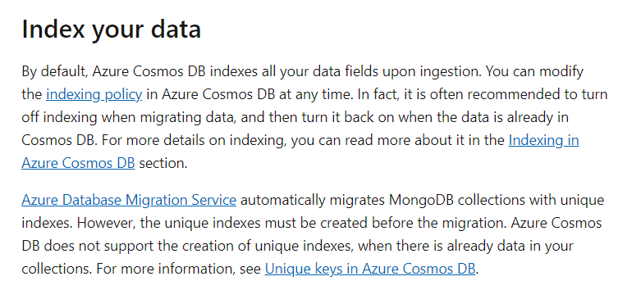

Since this is clearly mentioned in the Microsoft documentation, all other options are incorrect.

For more information on pre-migration steps for Mongo DB, please visit the below URL-

* <https://docs.microsoft.com/en-us/azure/cosmos-db/mongodb-pre-migration>

### **Question 18**

Domain :Design Azure data storage solutions

A company wants to deploy a set of databases using the Azure SQL database service. They want to organize the databases into separate groups based on database usage. They also want to have the ability to define the maximum limit on the resources that would be able for each group. Which of the following could be recommended to fulfill this requirement?

]A.

**Azure SQL Database Hyperscale**

]B.

**Azure SQL Database Single Instance**

]C.

**Azure SQL Database Elastic Pools**

]D.

**Azure SQL Database Sharding**

**Explanation:**

Answer – C

The ideal option for this requirement is to make use of SQL elastic pools.

The Microsoft documentation mentions the following.

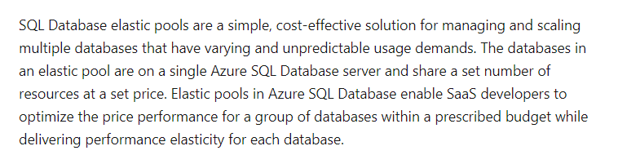

Since this is clearly mentioned in the Microsoft documentation, all other options are incorrect.

For more information on Azure SQL Database Elastic pools, please visit the below URL-

* <https://docs.microsoft.com/en-us/azure/sql-database/sql-database-elastic-pool>

### **Question 19**

Domain :Design Azure data storage solutions

A company wants to create an Azure storage account. Below are the requirements for the objects in the storage account.

* Storage costs should be minimized.
* The storage account will be used to hold objects which are infrequently accessed.
* The data in the storage account will be stored for at least 30 days.
* Data availability must be guaranteed at an SLA of 99%

Which of the following could be used as the underlying storage tier?

]A.

**Premium**

]B.

**Hot**

]C.

**Cold**

]D.

**Archive**

**Explanation:**

Answer – C

The ideal storage tier which fulfills all of the requirements is the Cold storage tier.

The Microsoft documentation mentions the following.

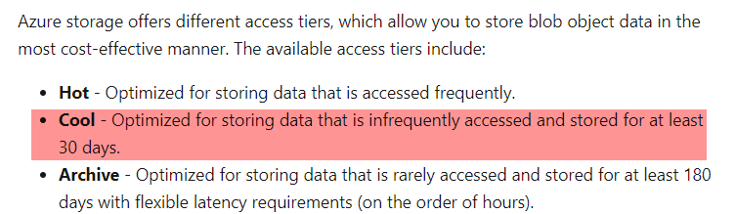

Since this is clearly mentioned in the Microsoft documentation, all other options are incorrect.

For more information on Azure storage account tiers, please visit the below URL-

* <https://docs.microsoft.com/en-us/azure/storage/blobs/storage-blob-storage-tiers>

### **Question 20**

Domain :Design Azure data storage solutions

A company wants to start using the Azure Databricks service. They want to ensure that the Databricks clusters remain available even at the time of regional Azure datacenter outages. Which of the following could be used as the redundancy type to fulfill this requirement?

]A.

**Read-access geo-redundant storage**

]B.

**Locally redundant storage**

]C.

**Geo-redundant storage**

]D.

**Zone-redundant storage**

**Explanation:**

Answer – C

You can make use of Geo-redundant storage.

The Microsoft documentation mentions the following.

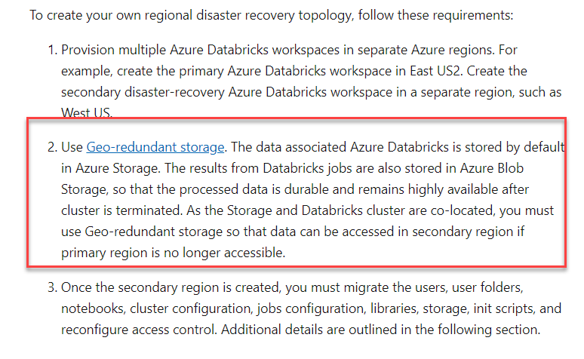

Since this is clearly mentioned in the Microsoft documentation, all other options are incorrect.

For more information on Azure Databricks redundancy, please visit the below URL-

* <https://docs.microsoft.com/en-us/azure/azure-databricks/howto-regional-disaster-recovery>

### **Question 21**

Domain :Design Azure data storage solutions

A company wants to use the Azure SQL database service. Business apps will be accessing the database. The application data must be available in the event of a region-wide outage. Below are the other key requirements.

* Data must be available in the secondary region if the primary region goes down.
* The storage and compute layers for the SQL database must be integrated and replicated together.

Which of the following would you use as the Service tier for the database?

]A.

**Basic**

]B.

**Standard**

]C.

**Premium**

]D.

**High**

**Explanation:**

Answer – C

The Premium service tier has support for replicating both the compute and storage layer.

The Microsoft documentation mentions the following.

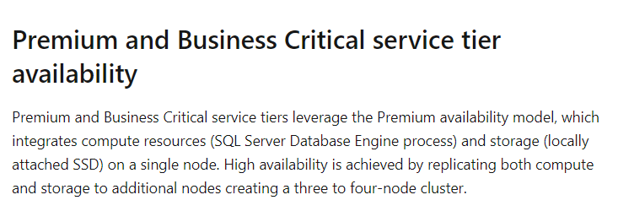

Since this is clearly mentioned in the Microsoft documentation, all other options are incorrect.

For more information on Azure SQL database high availability, please visit the below URL-

* <https://docs.microsoft.com/en-us/azure/sql-database/sql-database-high-availability>

### **Question 22**

Domain :Design Azure data storage solutions

A company wants to use the Azure SQL database service. Business apps will be accessing the database. The application data must be available in the event of a region-wide outage. Below are the other key requirements.

* Data must be available in the secondary region if the primary region goes down.
* The storage and compute layers for the SQL database must be integrated and replicated together.

Which of the following would you use as the redundancy type?

]A.

**SQL Sync**

]B.

**Zone-Redundancy**

]C.

**Geo-redundant storage**

]D.

**Local-redundant storage**

**Explanation:**

Answer – C

To ensure databases can be restored in another region, you should use geo-redundant storage.

The Microsoft documentation mentions the following.

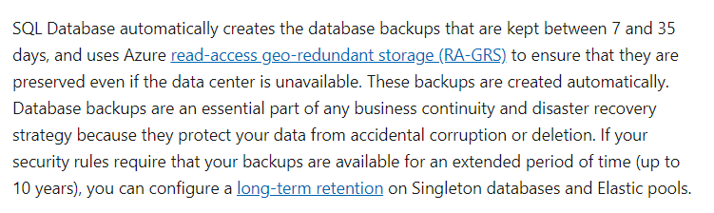

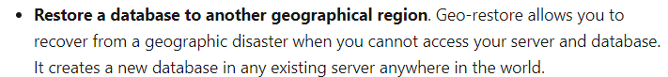

Since this is clearly mentioned in the Microsoft documentation, all other options are incorrect.

For more information on Azure SQL backups, please visit the below URL-

* <https://docs.microsoft.com/en-us/azure/sql-database/sql-database-automated-backups?tabs=single-database>

### **Question 23**

Domain :Design Azure data storage solutions

A company is planning to use the Azure SQL data warehouse service. Data would be uploaded to the data warehouse every week. Every time the data is uploaded, checks would be made to ensure that the data is not corrupted. If the data is corrupted, the uploaded data has to be removed. The upload process and data corruption check process must not impact the processes running against the warehouse.

The company decides to configure database-level auditing and set a retention period as part of the implementation process.

Would this meet the requirement?

]A.**Yes**

]B.**No**

**Explanation:**

Answer - B

The ideal solution would be to create a restore point and use the restore point to recover to an earlier point.

For more information on Azure SQL data warehouse backups, please visit the below URL-

* <https://docs.microsoft.com/en-us/azure/sql-data-warehouse/backup-and-restore>

### **Question 24**

Domain :Design Azure data storage solutions

A company is planning to use the Azure SQL data warehouse service. Data would be uploaded to the data warehouse every week. Every time the data is uploaded, checks would be made to ensure that the data is not corrupted. If the data is corrupted, the uploaded data has to be removed. The upload process and data corruption check process must not impact the processes running against the warehouse.

The company decides to create user-defined restore points before the data is uploaded. And then delete the restore point after the data corruption checks are complete.

Would this meet the requirement?

]A.**Yes**

]B.**No**

**Explanation:**

Answer – A

Yes, this would be an ideal step to include in the implementation plan.

The Microsoft documentation mentions the following.

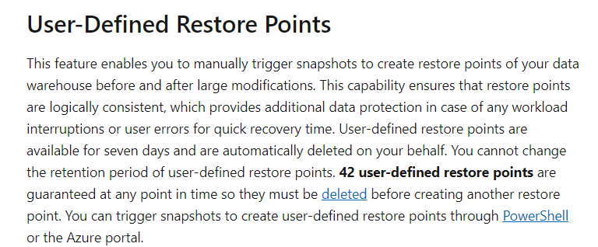

For more information on Azure SQL data warehouse backups, please visit the below URL-

* <https://docs.microsoft.com/en-us/azure/sql-data-warehouse/backup-and-restore>

### **Question 25**

Domain :Design Azure data storage solutions

A company is planning to use the Azure SQL data warehouse service. Data would be uploaded to the data warehouse every week. Every time the data is uploaded, checks would be made to ensure that the data is not corrupted. If the data is corrupted, the uploaded data has to be removed. The upload process and data corruption check process must not impact the processes running against the warehouse.

The company decides to configure transactions and then perform a rollback if data corruption is detected.

Would this meet the requirement?

]A.**Yes**

]B.**No**

**Explanation:**

Answer – B

The ideal solution would be to create a restore point. And use the restore point to recover to an earlier point.

For more information on Azure SQL data warehouse backups, please visit the below URL-

* <https://docs.microsoft.com/en-us/azure/sql-data-warehouse/backup-and-restore>

### **Question 26**

Domain :Design data processing solutions

A company wants to engineer a solution. The solution would have the following requirements.

* Ingest data from an on-premise SQL Server.
* Create pipelines that can integrate data and also run notebooks.
* Be able to develop notebooks that can be used to transform data.
* Be able to load the data into a massive parallel processing data for analysis.

Which of the following would you use as the service to integrate the on-premise data onto the cloud?

]A.

**Azure Databricks**

]B.

**Azure Data Factory**

]C.

**Azure SQL Data warehouse**

]D.

**Azure Batch**

**Explanation:**

Answer – B

You can transfer the data from your on-premise data store using Azure Data Factory. You can use the self-hosted runtime for this purpose.

The Microsoft documentation mentions the following.

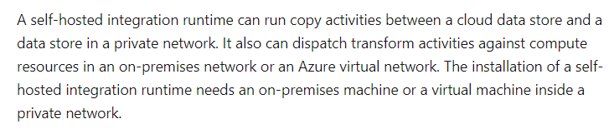

The other solutions can’t be used to transfer data.

For more information on the self-hosted runtime, please visit the below URL-

* <https://docs.microsoft.com/en-us/azure/data-factory/create-self-hosted-integration-runtime>

### **Question 27**

Domain :Design data processing solutions

A company wants to engineer a solution. The solution would have the following requirements.

* Ingest data from an on-premise SQL Server.
* Create pipelines that can integrate data and also run notebooks.
* Be able to develop notebooks that can be used to transform data.
* Be able to load the data into a massive parallel processing data for analysis.

Which of the following would you use as the service to develop notebooks to transform the data?

]A.

**Azure Databricks**

]B.

**Azure Data Factory**

]C.

**Azure SQL Data warehouse**

]D.

**Azure Batch**

**Explanation:**

Answer – A

You can create and work with notebooks using the Azure Databricks service.

The Microsoft documentation mentions the following.

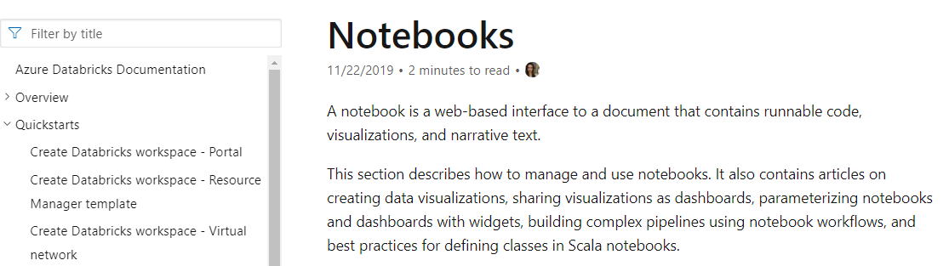

The other solutions don’t have the option of using notebooks.

For more information on Azure Databricks notebooks, please visit the below URL-

* <https://docs.microsoft.com/en-us/azure/databricks/notebooks/index>

### **Question 28**

Domain :Design data processing solutions

A company wants to engineer a solution. The solution would have the following requirements.

* Ingest data from an on-premise SQL Server.
* Create pipelines that can integrate data and also run notebooks.
* Be able to develop notebooks that can be used to transform data.
* Be able to load the data into a massive parallel processing data for analysis.

Which of the following would you use as the service to run notebooks?

]A.

**Azure Databricks**

]B.

**Azure Data Factory**

]C.

**Azure SQL Data warehouse**

]D.

**Azure Batch**

**Explanation:**

Answer – A

You can create and work with notebooks using the Azure Databricks service.

The Microsoft documentation mentions the following.



The other solutions don’t have the option of using notebooks.

For more information on Azure Databricks notebooks, please visit the below URL-

* <https://docs.microsoft.com/en-us/azure/databricks/notebooks/index>

### **Question 29**

Domain :Design data processing solutions

A company wants to engineer a solution. The solution would have the following requirements.

* Ingest data from an on-premise SQL Server.
* Create pipelines that can integrate data and also run notebooks.
* Be able to develop notebooks that can be used to transform data.
* Be able to load the data into a massive parallel processing data for analysis.

Which of the following would you use as the service to load the data?

]A.

**Azure Databricks**

]B.

**Azure Data Factory**

]C.

**Azure SQL Data warehouse**

]D.

**Azure Batch**

**Explanation:**

Answer – B

Azure Data Factory is a service that can be used to load and transform data.

The Microsoft documentation mentions the following.

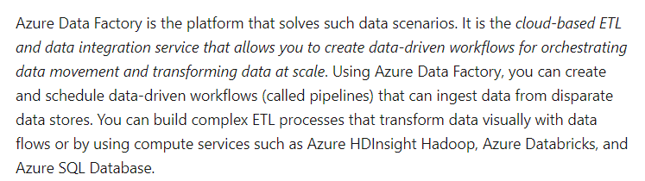

The other options are invalid because they are not the right services for loading data.

For more information on Azure Data Factory, please visit the below URL-

* <https://docs.microsoft.com/en-us/azure/data-factory/introduction>

### **Question 30**

Domain :Design data processing solutions

A company wants to engineer a solution. The solution would have the following requirements.

* Ingest data from an on-premise SQL Server.
* Create pipelines that can integrate data and also run notebooks.
* Be able to develop notebooks that can be used to transform data.
* Be able to load the data into a massive parallel processing data for analysis.

Which of the following would you use as the service to store the transformed data?

]A.

**Azure Databricks**

]B.

**Azure Data Factory**

]C.

**Azure SQL Data warehouse**

]D.

**Azure Batch**

**Explanation:**

Answer – C

The Azure SQL Data warehouse is a massive parallel processing data store.

The Microsoft documentation mentions the following.

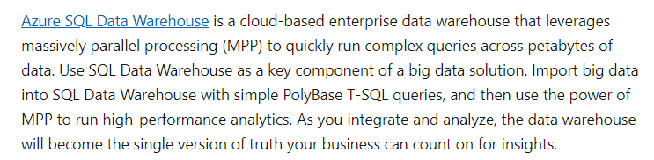

Since this is clearly mentioned in the documentation, all other options are incorrect.

For more information on Azure Data warehouse, please visit the below URL-

* <https://docs.microsoft.com/en-us/azure/databricks/data/data-sources/azure/sql-data-warehouse>

### **Question 31**

Domain :Design data processing solutions

Your company currently has a solution in place. This solution consists of streaming data being sent to Azure Event Hubs. The data is then stored in Azure Blob storage. The data contains social media posts.

You have to count the number of times the keyword Comps is mentioned in each post every 30 seconds. The data then needs to be available to Microsoft BI in near real-time.

You have to implement the new requirement for the solution.

You decide to use Azure Databricks to create a Scala notebook. You then create a structured streaming job to connect to the event hub. This would count the number of keywords in the post. The number is then written to a Delta table. You then go ahead to consume the data in PowerBI by using DirectQuery Mode.

Would this fulfill the requirement?

]A.**Yes**

]B.**No**

**Explanation:**

Answer – B

Here you should use Azure Stream Analytics to read and process the data from Azure Event Hubs.

For more information on using Azure Stream Analytics along with Azure Event Hubs, please visit the below URL-

* <https://docs.microsoft.com/en-us/azure/event-hubs/process-data-azure-stream-analytics>

### **Question 32**

Domain :Design data processing solutions

Your company currently has a solution in place. This solution consists of streaming data being sent to Azure Event Hubs. The data is then stored in Azure Blob storage. The data contains social media posts.

You have to count the number of times the keyword Comps is mentioned in each post every 30 seconds. The data then needs to be available to Microsoft BI in near real-time.

You have to implement the new requirement for the solution.

You decide to create an Azure Stream Analytics job. This would use Azure Event Hubs as the input stream. This would count the keywords and send the data to an Azure SQL Database. The data is then consumed in PowerBI by using DirectQuery Mode.

Would this fulfill the requirement?

]A.**Yes**

]B.**No**

**Explanation:**

Answer – A

Yes, this is the ideal approach wherein the data can be read and processed by Azure Stream Analytics.

The Microsoft documentation mentions the following.

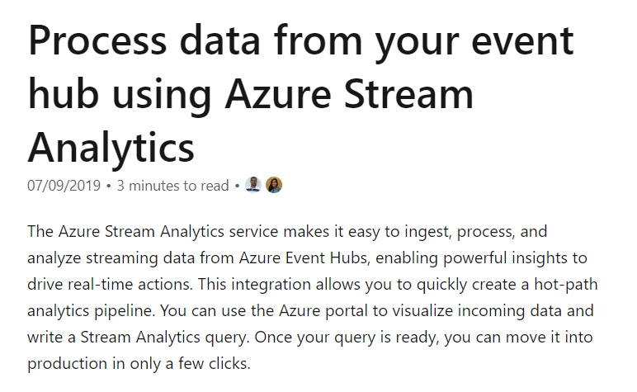

For more information on using Azure Stream Analytics along with Azure Event Hubs, please visit the below URL-

* <https://docs.microsoft.com/en-us/azure/event-hubs/process-data-azure-stream-analytics>

### **Question 33**

Domain :Design data processing solutions

Your company currently has a solution in place. This solution consists of streaming data being sent to Azure Event Hubs. The data is then stored in Azure Blob storage. The data contains social media posts.

You have to count the number of times the keyword Comps is mentioned in each post every 30 seconds. The data then needs to be available to Microsoft BI in near real-time.

You have to implement the new requirement for the solution.

You plan to use Azure Data Factory and an event trigger to detect when new blobs are added to the storage account. You then filter the data in Azure Data Factory and then send the data to an Azure SQL Database. The data is then consumed in PowerBI by using DirectQuery Mode.

Would this fulfill the requirement?

]A.**Yes**

]B.**No**

**Explanation:**

Answer – B

Here you should use Azure Stream Analytics to read and process the data from Azure Event Hubs.

For more information on using Azure Stream Analytics along with Azure Event Hubs, please visit the below URL-

* <https://docs.microsoft.com/en-us/azure/event-hubs/process-data-azure-stream-analytics>

### **Question 34**

Domain :Design Azure data storage solutions

[**View Case Study**](javascript:;)

**Overview**

A company is responsible for designing a new data engineering solution. The solution would be used by a media company that has offices in the following locations

* New York
* Manchester
* Singapore
* Melbourne

**Current environment**

* The current solution stores millions of images on a physical server that is located in the New York office.
* Around 2 TB of images are added every day
* Currently the images are not being organized properly
* It becomes difficult to search for images
* The images need to have object and color tags generated
* The tags are stored in a document database that is queries by SQL
* The New York office also has a Microsoft SQL Server database that stores customer data

**Proposed environment**

* All of the images and any customer data needs to be transferred to Azure.
* On-premise servers need to be decommissioned
* A proper analytical processing solution must be in place for customer related data
* There should be a proper image object and color tagging solution in place
* All expenses must be minimized
* The tagging data must be uploaded from the New York Office location
* Tagging data must be replicated to regions where other offices are located
* The customer data must be analyzed using Spark clusters
* The cluster should allow for parallel processing of data
* Power BI must be used to visualize transformed customer data
* There should be a facility to backup data if disaster recovery is required
* All the data in the cloud must be encrypted at rest and in transit
* Images must be replicated globally

You have to choose the right service for storing image tagging data. Which of the following should be used to fulfill this requirement?

]A.

**Azure File storage**

]B.

**Azure Blob storage**

]C.

**Azure Cosmos DB**

]D.

**Azure SQL Data warehouse**

**Explanation:**

Answer – C

The data was stored in an on-premise data store. We need to use Cosmos DB which can be used as a document-based data store. This is supported via the SQL API.

The Microsoft documentation mentions the following.



Since this is the ideal data store, all other options are incorrect.

For more information on Azure Cosmos DB SQL API, please visit the below URL-

* <https://docs.microsoft.com/en-us/azure/cosmos-db/sql-query-getting-started>

### **Question 35**

Domain :Design data processing solutions

[**View Case Study**](javascript:;)

**Overview**

A company is responsible for designing a new data engineering solution. The solution would be used by a media company that has offices in the following locations

* New York
* Manchester
* Singapore
* Melbourne

**Current environment**

* The current solution stores millions of images on a physical server that is located in the New York office.
* Around 2 TB of images are added every day
* Currently the images are not being organized properly
* It becomes difficult to search for images
* The images need to have object and color tags generated
* The tags are stored in a document database that is queries by SQL
* The New York office also has a Microsoft SQL Server database that stores customer data

**Proposed environment**

* All of the images and any customer data needs to be transferred to Azure.
* On-premise servers need to be decommissioned
* A proper analytical processing solution must be in place for customer related data
* There should be a proper image object and color tagging solution in place
* All expenses must be minimized
* The tagging data must be uploaded from the New York Office location
* Tagging data must be replicated to regions where other offices are located
* The customer data must be analyzed using Spark clusters
* The cluster should allow for parallel processing of data
* Power BI must be used to visualize transformed customer data
* There should be a facility to backup data if disaster recovery is required
* All the data in the cloud must be encrypted at rest and in transit
* Images must be replicated globally

You need to ensure that the following requirement is met.

**“A proper analytical processing solution must be in place for customer-related data.”**

Which of the following would you use for this requirement?

]A.

**Azure Databricks**

]B.

**Azure Data Lake Storage**

]C.

**Azure Data warehouse**

]D.

**Azure Cosmos DB**

**Explanation:**

Answer – A

You can use Azure Databricks as a processing solution.

The Microsoft documentation mentions the following.

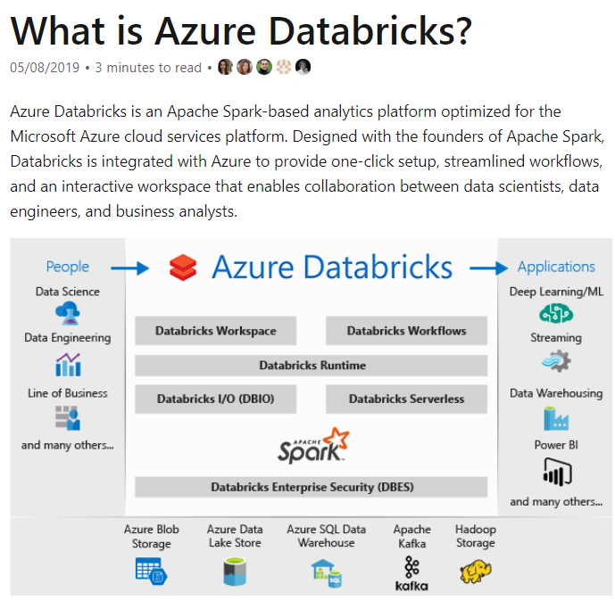

All of the other options are incorrect since these are all data storage solutions.

For more information on Azure Databricks, please visit the below URL-

* <https://docs.microsoft.com/en-us/azure/azure-databricks/what-is-azure-databricks>

### **Question 36**

Domain :Design Azure data storage solutions

[**View Case Study**](javascript:;)

**Overview**

A company is responsible for designing a new data engineering solution. The solution would be used by a media company that has offices in the following locations

* New York
* Manchester
* Singapore
* Melbourne

**Current environment**

* The current solution stores millions of images on a physical server that is located in the New York office.
* Around 2 TB of images are added every day
* Currently the images are not being organized properly
* It becomes difficult to search for images
* The images need to have object and color tags generated
* The tags are stored in a document database that is queries by SQL
* The New York office also has a Microsoft SQL Server database that stores customer data

**Proposed environment**

* All of the images and any customer data needs to be transferred to Azure.
* On-premise servers need to be decommissioned
* A proper analytical processing solution must be in place for customer related data
* There should be a proper image object and color tagging solution in place
* All expenses must be minimized
* The tagging data must be uploaded from the New York Office location
* Tagging data must be replicated to regions where other offices are located
* The customer data must be analyzed using Spark clusters
* The cluster should allow for parallel processing of data
* Power BI must be used to visualize transformed customer data
* There should be a facility to backup data if disaster recovery is required
* All the data in the cloud must be encrypted at rest and in transit
* Images must be replicated globally

You need to meet the storage requirements for the image tagging data. Which of the following would you configure for the data store in the New York location?

]A.

**Primary Region**

]B.

**Secondary Region**

]C.

**Write Region**

]D.

**Read Region**

**Explanation:**

Answer – C

The tagging data would be transferred to Cosmos DB from the New York location. This should be set as the write region for the Cosmos DB database.

Options A and B are incorrect since you need to configure either read or write regions.

Option D is incorrect since we need to configure this region as the write region.

For more information on Cosmos DB global distribution, please visit the below URL-

* <https://docs.microsoft.com/en-us/azure/cosmos-db/distribute-data-globally>

### **Question 37**

Domain :Design Azure data storage solutions

[**View Case Study**](javascript:;)

**Overview**

A company is responsible for designing a new data engineering solution. The solution would be used by a media company that has offices in the following locations

* New York
* Manchester
* Singapore
* Melbourne

**Current environment**

* The current solution stores millions of images on a physical server that is located in the New York office.
* Around 2 TB of images are added every day
* Currently the images are not being organized properly
* It becomes difficult to search for images
* The images need to have object and color tags generated
* The tags are stored in a document database that is queries by SQL
* The New York office also has a Microsoft SQL Server database that stores customer data

**Proposed environment**

* All of the images and any customer data needs to be transferred to Azure.
* On-premise servers need to be decommissioned
* A proper analytical processing solution must be in place for customer related data
* There should be a proper image object and color tagging solution in place
* All expenses must be minimized
* The tagging data must be uploaded from the New York Office location
* Tagging data must be replicated to regions where other offices are located
* The customer data must be analyzed using Spark clusters
* The cluster should allow for parallel processing of data
* Power BI must be used to visualize transformed customer data
* There should be a facility to backup data if disaster recovery is required
* All the data in the cloud must be encrypted at rest and in transit
* Images must be replicated globally

You need to meet the storage requirements for the image tagging data. Which of the following would you configure for the data store in the New York location?

]A.

**Primary Region**

]B.

**Secondary Region**

]C.

**Write Region**

]D.

**Read Region**

**Explanation:**

Answer – D

The tagging data would be transferred to Cosmos DB from the New York location. The other regions must also have the data. We need to configure the other locations as read regions.

Options A and B are incorrect since you need to configure either read or write regions.

Option C is incorrect since we need to configure the other regions as read regions.

For more information on Cosmos DB global distribution, please visit the below URL-

* <https://docs.microsoft.com/en-us/azure/cosmos-db/distribute-data-globally>

### **Question 38**

Domain :Design Azure data storage solutions

[**View Case Study**](javascript:;)

**Overview**

A company is responsible for designing a new data engineering solution. The solution would be used by a media company that has offices in the following locations

* New York
* Manchester
* Singapore
* Melbourne

**Current environment**

* The current solution stores millions of images on a physical server that is located in the New York office.
* Around 2 TB of images are added every day
* Currently the images are not being organized properly
* It becomes difficult to search for images
* The images need to have object and color tags generated
* The tags are stored in a document database that is queries by SQL
* The New York office also has a Microsoft SQL Server database that stores customer data

**Proposed environment**

* All of the images and any customer data needs to be transferred to Azure.
* On-premise servers need to be decommissioned
* A proper analytical processing solution must be in place for customer related data
* There should be a proper image object and color tagging solution in place
* All expenses must be minimized
* The tagging data must be uploaded from the New York Office location
* Tagging data must be replicated to regions where other offices are located
* The customer data must be analyzed using Spark clusters
* The cluster should allow for parallel processing of data
* Power BI must be used to visualize transformed customer data
* There should be a facility to backup data if disaster recovery is required
* All the data in the cloud must be encrypted at rest and in transit
* Images must be replicated globally

You need to meet the storage requirements for the image tagging data. Which of the following would you configure for the data store in the New York location?

]A.

**Primary Region**

]B.

**Secondary Region**

]C.

**Write Region**

]D.

**Read Region**

**Explanation:**

Answer – D

The tagging data would be transferred to Cosmos DB from the New York location. The other regions must also have the data. We need to configure the other locations as read regions.

Options A and B are incorrect since you need to configure either read or write regions.

Option C is incorrect since we need to configure the other regions as read regions.

For more information on Cosmos DB global distribution, please visit the below URL-

* <https://docs.microsoft.com/en-us/azure/cosmos-db/distribute-data-globally>

### **Question 39**

Domain :Design Azure data storage solutions

[**View Case Study**](javascript:;)

**Overview**

A company is responsible for designing a new data engineering solution. The solution would be used by a media company that has offices in the following locations

* New York
* Manchester
* Singapore
* Melbourne

**Current environment**

* The current solution stores millions of images on a physical server that is located in the New York office.
* Around 2 TB of images are added every day
* Currently the images are not being organized properly
* It becomes difficult to search for images
* The images need to have object and color tags generated
* The tags are stored in a document database that is queries by SQL
* The New York office also has a Microsoft SQL Server database that stores customer data

**Proposed environment**

* All of the images and any customer data needs to be transferred to Azure.
* On-premise servers need to be decommissioned
* A proper analytical processing solution must be in place for customer related data
* There should be a proper image object and color tagging solution in place
* All expenses must be minimized
* The tagging data must be uploaded from the New York Office location
* Tagging data must be replicated to regions where other offices are located
* The customer data must be analyzed using Spark clusters
* The cluster should allow for parallel processing of data
* Power BI must be used to visualize transformed customer data
* There should be a facility to backup data if disaster recovery is required
* All the data in the cloud must be encrypted at rest and in transit
* Images must be replicated globally

You need to meet the storage requirements for the image tagging data. Which of the following would you configure for the data store in the New York location?

]A.

**Primary Region**

]B.

**Secondary Region**

]C.

**Write Region**

]D.

**Read Region**

**Explanation:**

Answer – D

The tagging data would be transferred to Cosmos DB from the New York location. The other regions must also have the data. We need to configure the other locations as read regions.

Options A and B are incorrect since you need to configure either read or write regions.

Option C is incorrect since we need to configure the other regions as read regions.

For more information on Cosmos DB global distribution, please visit the below URL-

* <https://docs.microsoft.com/en-us/azure/cosmos-db/distribute-data-globally>

### **Question 40**

Domain :Design for data security and compliance

[**View Case Study**](javascript:;)

**Overview**

A company is responsible for designing a new data engineering solution. The solution would be used by a media company that has offices in the following locations

* New York
* Manchester
* Singapore
* Melbourne

**Current environment**

* The current solution stores millions of images on a physical server that is located in the New York office.
* Around 2 TB of images are added every day
* Currently the images are not being organized properly
* It becomes difficult to search for images
* The images need to have object and color tags generated
* The tags are stored in a document database that is queries by SQL
* The New York office also has a Microsoft SQL Server database that stores customer data

**Proposed environment**

* All of the images and any customer data needs to be transferred to Azure.
* On-premise servers need to be decommissioned
* A proper analytical processing solution must be in place for customer related data
* There should be a proper image object and color tagging solution in place
* All expenses must be minimized
* The tagging data must be uploaded from the New York Office location
* Tagging data must be replicated to regions where other offices are located
* The customer data must be analyzed using Spark clusters
* The cluster should allow for parallel processing of data
* Power BI must be used to visualize transformed customer data
* There should be a facility to backup data if disaster recovery is required
* All the data in the cloud must be encrypted at rest and in transit
* Images must be replicated globally

You have to ensure that the security requirements are met for the tagging data. Which of the following would you implement for this requirement?

]A.

**Encryption at rest**

]B.

**Transparent data encryption**

]C.

**Azure Key vault**

]D.

**Certificate store**

**Explanation:**

Answer – A

Since the tagging data will be in Cosmos DB, Cosmos DB already has the facility of encryption at rest.

The Microsoft documentation mentions the following.

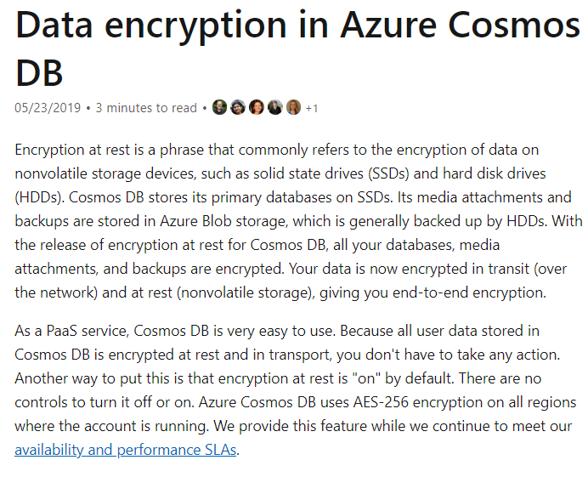

Since this is clear from the Microsoft documentation, all other options are incorrect.

For more information on Cosmos DB encryption at rest, please visit the below URL-

* <https://docs.microsoft.com/en-us/azure/cosmos-db/database-encryption-at-rest>

### **Question 41**

Domain :Design for data security and compliance

[**View Case Study**](javascript:;)

**Overview**

A company is responsible for designing a new data engineering solution. The solution would be used by a media company that has offices in the following locations

* New York
* Manchester
* Singapore
* Melbourne

**Current environment**

* The current solution stores millions of images on a physical server that is located in the New York office.
* Around 2 TB of images are added every day
* Currently the images are not being organized properly
* It becomes difficult to search for images
* The images need to have object and color tags generated
* The tags are stored in a document database that is queries by SQL
* The New York office also has a Microsoft SQL Server database that stores customer data

**Proposed environment**

* All of the images and any customer data needs to be transferred to Azure.
* On-premise servers need to be decommissioned
* A proper analytical processing solution must be in place for customer related data
* There should be a proper image object and color tagging solution in place
* All expenses must be minimized
* The tagging data must be uploaded from the New York Office location
* Tagging data must be replicated to regions where other offices are located
* The customer data must be analyzed using Spark clusters
* The cluster should allow for parallel processing of data
* Power BI must be used to visualize transformed customer data
* There should be a facility to backup data if disaster recovery is required
* All the data in the cloud must be encrypted at rest and in transit
* Images must be replicated globally

You have to ensure that the security requirements are met for the customer data. Which of the following would you implement for this requirement?

]A.

**Encryption at rest**

]B.

**Transparent data encryption**

]C.

**Azure Key vault**

]D.

**Certificate store**

**Explanation:**

Answer – B

The customer data will be stored in an Azure SQL Database. We can use Transparent Data encryption to encrypt the data at rest.

The Microsoft documentation mentions the following.

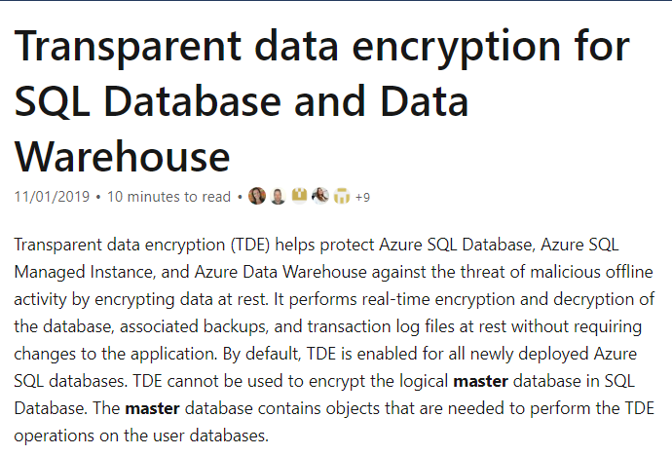

Since this is clear from the Microsoft documentation, all other options are incorrect.

For more information on Transparent Data Encryption, please visit the below URL-

* <https://docs.microsoft.com/en-us/azure/sql-database/transparent-data-encryption-azure-sql?tabs=azure-portal>

### **Question 42**

Domain :Design for data security and compliance

[**View Case Study**](javascript:;)

**Overview**

A company is responsible for designing a new data engineering solution. The solution would be used by a media company that has offices in the following locations

* New York
* Manchester
* Singapore
* Melbourne

**Current environment**

* The current solution stores millions of images on a physical server that is located in the New York office.
* Around 2 TB of images are added every day
* Currently the images are not being organized properly
* It becomes difficult to search for images
* The images need to have object and color tags generated
* The tags are stored in a document database that is queries by SQL
* The New York office also has a Microsoft SQL Server database that stores customer data

**Proposed environment**

* All of the images and any customer data needs to be transferred to Azure.
* On-premise servers need to be decommissioned
* A proper analytical processing solution must be in place for customer related data
* There should be a proper image object and color tagging solution in place
* All expenses must be minimized
* The tagging data must be uploaded from the New York Office location
* Tagging data must be replicated to regions where other offices are located
* The customer data must be analyzed using Spark clusters
* The cluster should allow for parallel processing of data
* Power BI must be used to visualize transformed customer data
* There should be a facility to backup data if disaster recovery is required
* All the data in the cloud must be encrypted at rest and in transit
* Images must be replicated globally

You need to comply with the following requirement for the customer data.

**“There should be a facility to backup data if disaster recovery is required.”**

Which of the following would you implement for this requirement?

]A.

**Geo-redundancy**

]B.

**Global tables**

]C.

**Geo-replication**

]D.

**Active-replication**

**Explanation:**

Answer – A

You can use Geo-redundancy, which can be used to recover a database.

The Microsoft documentation mentions the following.

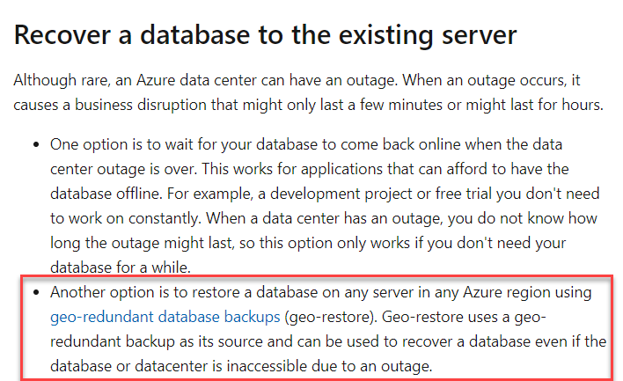

This would be a more cost-effective option that Option C, which is Geo-replication.

For more information on business continuity for Azure SQL databases, please visit the below URL-

* <https://docs.microsoft.com/en-us/azure/sql-database/sql-database-business-continuity>

### **Question 43**

Domain :Design Azure data storage solutions

[**View Case Study**](javascript:;)

**Overview**

A company is responsible for designing a new data engineering solution. The solution would be used by a media company that has offices in the following locations

* New York
* Manchester
* Singapore
* Melbourne

**Current environment**

* The current solution stores millions of images on a physical server that is located in the New York office.
* Around 2 TB of images are added every day
* Currently the images are not being organized properly
* It becomes difficult to search for images
* The images need to have object and color tags generated
* The tags are stored in a document database that is queries by SQL
* The New York office also has a Microsoft SQL Server database that stores customer data

**Proposed environment**

* All of the images and any customer data needs to be transferred to Azure.
* On-premise servers need to be decommissioned
* A proper analytical processing solution must be in place for customer related data
* There should be a proper image object and color tagging solution in place
* All expenses must be minimized
* The tagging data must be uploaded from the New York Office location
* Tagging data must be replicated to regions where other offices are located
* The customer data must be analyzed using Spark clusters
* The cluster should allow for parallel processing of data
* Power BI must be used to visualize transformed customer data
* There should be a facility to backup data if disaster recovery is required
* All the data in the cloud must be encrypted at rest and in transit
* Images must be replicated globally

You need to decide on a storage solution for the images. Which of the following would you choose for this requirement?

]A.

**Azure Blob storage**

]B.

**Azure Data Lake storage**

]C.

**Azure SQL Database**

]D.

**Azure SQL Data Warehouse**

**Explanation:**

Answer – B

You can use Azure Data Lake Storage for Big data requirements. Since many images get uploaded every day, this would be the ideal storage location.

The Microsoft documentation mentions the following.

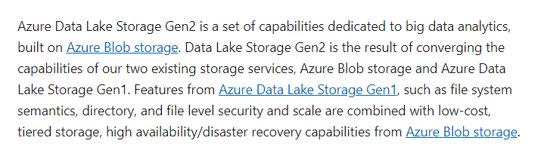

Option A is incorrect since Data Lake Storage built on top of Blob storage is ideal for this requirement.

Option C is incorrect since this is a relational data store.

Option D is incorrect since this is a data warehousing solution.

For more information on Azure Data Lake Storage, please visit the below URL-

* <https://docs.microsoft.com/en-us/azure/storage/blobs/data-lake-storage-introduction>

### **Question 44**

Domain :Design for data security and compliance

[**View Case Study**](javascript:;)

**Overview**

A company is responsible for designing a new data engineering solution. The solution would be used by a media company that has offices in the following locations

* New York
* Manchester
* Singapore
* Melbourne

**Current environment**

* The current solution stores millions of images on a physical server that is located in the New York office.
* Around 2 TB of images are added every day
* Currently the images are not being organized properly
* It becomes difficult to search for images
* The images need to have object and color tags generated
* The tags are stored in a document database that is queries by SQL
* The New York office also has a Microsoft SQL Server database that stores customer data

**Proposed environment**

* All of the images and any customer data needs to be transferred to Azure.
* On-premise servers need to be decommissioned
* A proper analytical processing solution must be in place for customer related data
* There should be a proper image object and color tagging solution in place
* All expenses must be minimized
* The tagging data must be uploaded from the New York Office location
* Tagging data must be replicated to regions where other offices are located
* The customer data must be analyzed using Spark clusters
* The cluster should allow for parallel processing of data
* Power BI must be used to visualize transformed customer data
* There should be a facility to backup data if disaster recovery is required
* All the data in the cloud must be encrypted at rest and in transit
* Images must be replicated globally

You need to allow users from the on-premise network to access the Azure SQL database. Which of the following would you set for this requirement?

]A.

**A server-level virtual network rule**

]B.

**A database-level virtual network rule**

]C.

**A server-level firewall rule**

]D.

**A database-level firewall rule**

**Explanation:**

Answer – C

We need to set a server-level firewall rule.

This is also given in the Microsoft documentation.

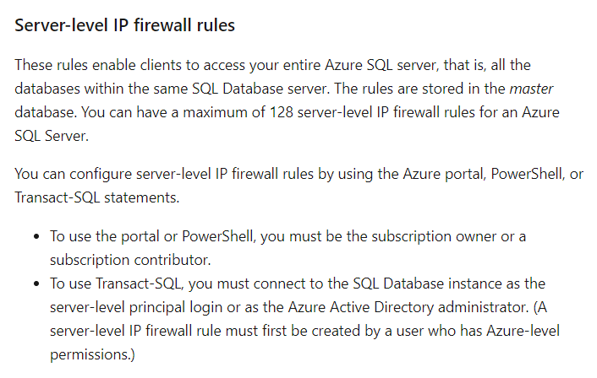

Since this is clear from the Microsoft documentation, all other options are incorrect.

For more information on firewall configuration for Azure SQL, please visit the below URL-

* <https://docs.microsoft.com/en-us/azure/sql-database/sql-database-firewall-configure>

### **Question 45**

Domain :Design Azure data storage solutions

A company wants to set up a set of data stores on Azure. Each datastore has different requirements.

* Datastore1 – This datastore must be able to store JSON related data. It must also have the ability to replicate data to multiple regions.
* Datastore2 – This would behave as an OLTP store.
* Datastore3 – On this data store, one should be able to run queries across petabytes of data.
* Datastore4 – This store should be able to ingest large amounts of images per day.

Which of the following technology would you use for Datastore1?

]A.

**Azure SQL Database**

]B.

**Azure Cosmos DB**

]C.

**Azure SQL Data Warehouse**

]D.

**Azure Data Lake Storage**

**Explanation:**

Answer – B

The ideal data store that can store JSON related data is Cosmos DB.

The Microsoft documentation mentions the following.



Since this is clear from the Microsoft documentation, all other options are incorrect.

For more information on the SQL API for Cosmos DB, please visit the below URL-

* <https://docs.microsoft.com/en-us/azure/cosmos-db/sql-query-getting-started>

### **Question 46**

Domain :Design Azure data storage solutions

A company wants to set up a set of data stores on Azure. Each datastore has different requirements.

* Datastore1 – This datastore must be able to store JSON related data. It must also have the ability to replicate data to multiple regions.
* Datastore2 – This would behave as an OLTP store.
* Datastore3 – On this data store, one should be able to run queries across petabytes of data.
* Datastore4 – This store should be able to ingest large amounts of images per day.

Which of the following technology would you use for Datastore2?

]A.

**Azure SQL Database**

]B.

**Azure Cosmos DB**

]C.

**Azure SQL Data Warehouse**

]D.

**Azure Data Lake Storage**

**Explanation:**

Answer – A

An OLTP data store would undergo a lot of transactions. The ideal store would be an Azure SQL Database.

The Microsoft documentation mentions the following.



Since this is the ideal candidate for the data store, all other options are incorrect.

For more information on SQL database in-memory technologies, please visit the below URL-

* <https://docs.microsoft.com/en-us/azure/sql-database/sql-database-in-memory>

### **Question 47**

Domain :Design Azure data storage solutions

A company wants to set up a set of data stores on Azure. Each datastore has different requirements.

* Datastore1 – This datastore must be able to store JSON related data. It must also have the ability to replicate data to multiple regions.
* Datastore2 – This would behave as an OLTP store.
* Datastore3 – On this data store, one should be able to run queries across petabytes of data.
* Datastore4 – This store should be able to ingest large amounts of images per day.

Which of the following technology would you use for Datastore3?

]A.

**Azure SQL Database**

]B.

**Azure Cosmos DB**

]C.

**Azure SQL Data Warehouse**

]D.

**Azure Data Lake Storage**

**Explanation:**

Answer – C

Azure SQL Data Warehouse would be the ideal candidate for OLAP workloads.

The Microsoft documentation mentions the following.

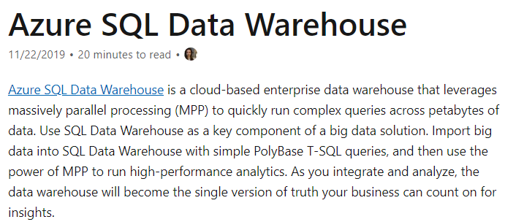

Since this is clear from the Microsoft documentation, all other options are incorrect.

For more information on Azure SQL data warehouse, please visit the below URL-

* <https://docs.microsoft.com/en-us/azure/databricks/data/data-sources/azure/sql-data-warehouse>

### **Question 48**

Domain :Design Azure data storage solutions

A company wants to set up a set of data stores on Azure. Each datastore has different requirements.

* Datastore1 – This datastore must be able to store JSON related data. It must also have the ability to replicate data to multiple regions.
* Datastore2 – This would behave as an OLTP store.
* Datastore3 – On this data store, one should be able to run queries across petabytes of data.
* Datastore4 – This store should be able to ingest large amounts of images per day.

Which of the following technology would you use for Datastore4?

]A.

**Azure SQL Database**

]B.

**Azure Cosmos DB**

]C.

**Azure SQL Data Warehouse**

]D.

**Azure Data Lake Storage**

**Explanation:**

Answer – D

Azure SQL Data Lake storage would be the ideal candidate for this requirement.

The Microsoft documentation mentions the following.

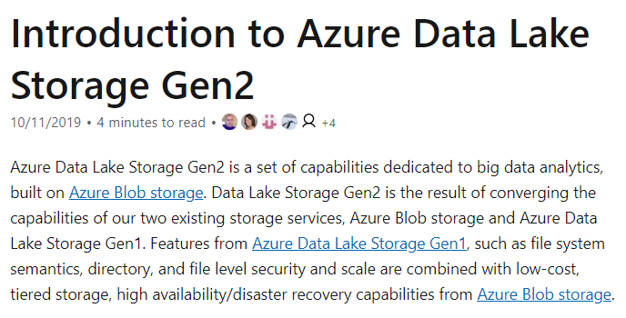

Since this is clear from the Microsoft documentation, all other options are incorrect.

For more information on Azure Data Lake Storage, please visit the below URL-

* <https://docs.microsoft.com/en-us/azure/storage/blobs/data-lake-storage-introduction>

### **Question 49**

Domain :Design data processing solutions

A company plans to use the Azure Databricks service. They want to create persistent clusters that would support auto-scaling for analytical processes.

The company decides to create a Standard cluster.

Would this fulfill the requirement?

]A.**Yes**

]B.**No**

**Explanation:**

Answer – B

No, this type of cluster would have auto-termination enabled.

The Microsoft documentation mentions the following.

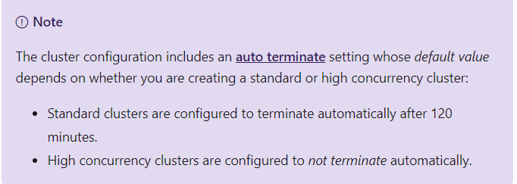

For more information on Azure Databricks clusters, please visit the below URL-

* <https://docs.microsoft.com/en-us/azure/databricks/clusters/configure>

### **Question 50**

Domain :Design data processing solutions

A company plans to use the Azure Databricks service. They want to create persistent clusters that would support auto-scaling for analytical processes.

The company decides to create a High concurrency cluster.

Would this fulfill the requirement?

]A.**Yes**

]B.**No**

**Explanation:**

Answer – A

Yes, this is the right approach.

The Microsoft documentation mentions the following.



For more information on Azure Databricks clusters, please visit the below URL-

* <https://docs.microsoft.com/en-us/azure/databricks/clusters/configure>

### **Question 51**

Domain :Design data processing solutions

A company plans to use the Azure Databricks service. They want to create persistent clusters that would support auto-scaling for analytical processes.

The company decides to create a Premium cluster.

Would this fulfill the requirement?

]A.**Yes**

]B.**No**

**Explanation:**

Answer – B

Currently, there are only Standard and High Concurrency clusters.

The Microsoft documentation mentions the following.



For more information on Azure Databricks clusters, please visit the below URL-

* <https://docs.microsoft.com/en-us/azure/databricks/clusters/configure>

### **Question 52**

Domain :Design data processing solutions

A company is designing a complete end-to-end solution for data analytics.

The overall architecture is given below.

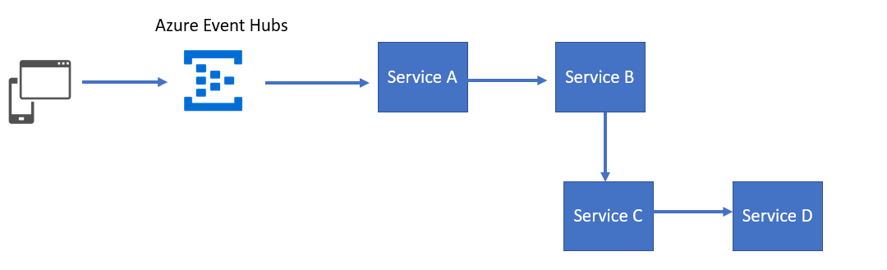

* Azure Event Hubs would be used to ingest data from multiple devices.
* The data needs to be processed by Service A and sent to a relational store services by Service B.
* Every month, an ETL service (Service C) needs to run and store the output data in a columnar data store hosted by Service D.

Which of the following would you use as Service A?

]A.

**Azure SQL Database**

]B.

**Azure Stream Analytics**

]C.

**Azure SQL Data Warehouse**

]D.

**Azure Data Factory**

**Explanation:**

Answer – B

Azure Stream Analytics can take the data from Azure Event Hubs for processing.

The Microsoft documentation mentions the following.

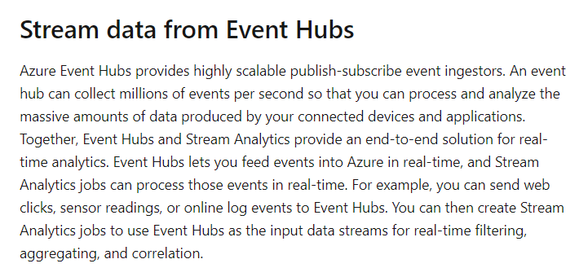

Since this is clear from the Microsoft documentation, all other options are incorrect.

For more information on using Azure Stream Analytics with Event Hubs, please visit the below URL-

* <https://docs.microsoft.com/en-us/azure/stream-analytics/stream-analytics-define-inputs>

### **Question 53**

Domain :Design data processing solutions

A company is designing a complete end-to-end solution for data analytics.

The overall architecture is given below.



* Azure Event Hubs would be used to ingest data from multiple devices.
* The data needs to be processed by Service A and sent to a relational store services by Service B.
* Every month, an ETL service (Service C) needs to run and store the output data in a columnar data store hosted by Service D.

Which of the following would you use as Service B?

]A.

**Azure SQL Database**

]B.

**Azure Stream Analytics**

]C.

**Azure SQL Data Warehouse**

]D.

**Azure Data Factory**

**Explanation:**

Answer – A

You can use Azure SQL Database as the relational data store.

The Microsoft documentation mentions the following.

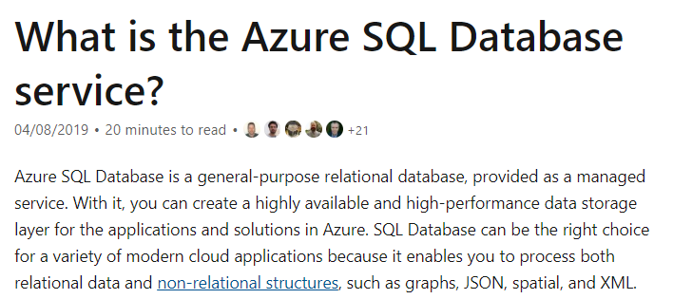

Since this is clear from the Microsoft documentation, all other options are incorrect.

For more information on using the Azure SQL database, please visit the below URL-

* <https://docs.microsoft.com/en-us/azure/sql-database/sql-database-technical-overview>

### **Question 54**

Domain :Design data processing solutions

A company is designing a complete end-to-end solution for data analytics.

The overall architecture is given below.



* Azure Event Hubs would be used to ingest data from multiple devices.
* The data needs to be processed by Service A and sent to a relational store services by Service B.
* Every month, an ETL service (Service C) needs to run and store the output data in a columnar data store hosted by Service D.

Which of the following would you use as Service C?

]A.

**Azure SQL Database**

]B.

**Azure Stream Analytics**

]C.

**Azure SQL Data Warehouse**

]D.

**Azure Data Factory**

**Explanation:**

Answer – D

Azure Data Factory can be used as the ETL service.

The Microsoft documentation mentions the following.

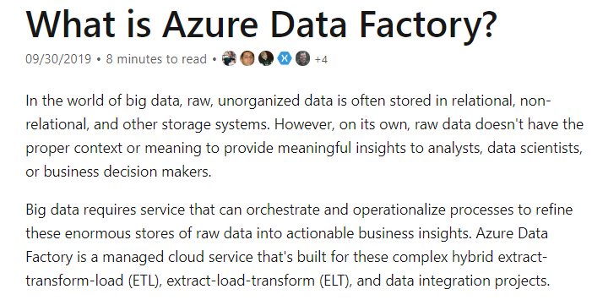

Since this is clear from the Microsoft documentation, all other options are incorrect.

For more information on using Azure Data Factory, please visit the below URL-

* <https://docs.microsoft.com/en-us/azure/data-factory/introduction>

### **Question 55**

Domain :Design data processing solutions

A company is designing a complete end-to-end solution for data analytics.

The overall architecture is given below.



* Azure Event Hubs would be used to ingest data from multiple devices.
* The data needs to be processed by Service A and sent to a relational store services by Service B.
* Every month, an ETL service (Service C) needs to run and store the output data in a columnar data store hosted by Service D.

Which of the following would you use as Service D?

]A.

**Azure SQL Database**

]B.

**Azure Stream Analytics**

]C.

**Azure SQL Data Warehouse**

]D.

**Azure Data Factory**

**Explanation:**

Answer – C

Azure SQL Data Warehouse is a columnar data store.

The Microsoft documentation mentions the following.

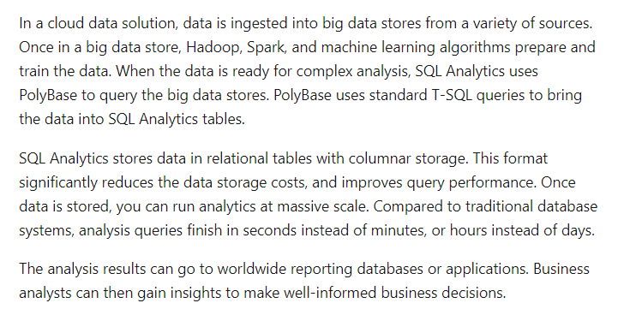

Since this is clear from the Microsoft documentation, all other options are incorrect.

For more information on using Azure SQL Data Warehouse, please visit the below URL-

* <https://docs.microsoft.com/en-us/azure/sql-data-warehouse/sql-data-warehouse-overview-what-is>